1. Continuous Graph

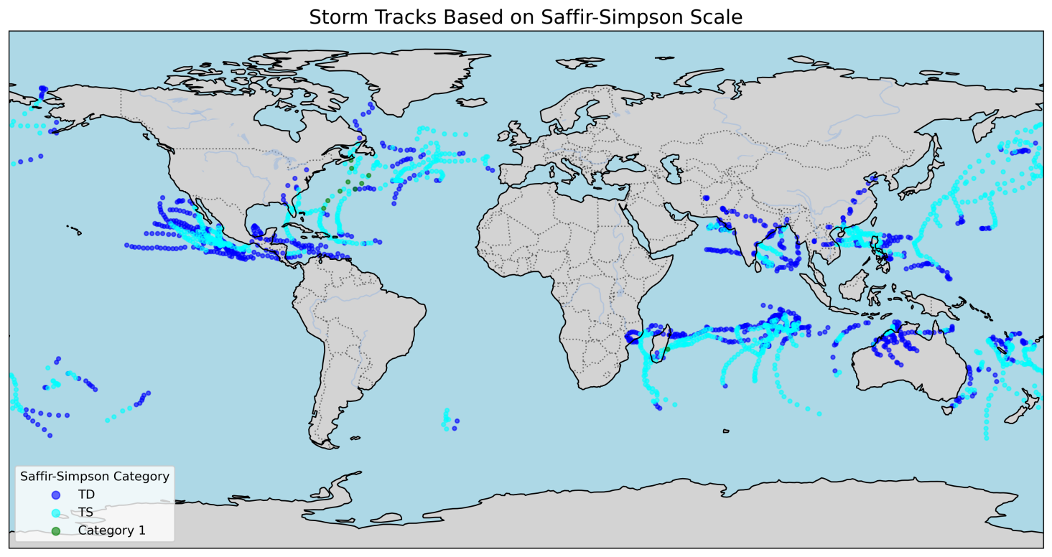

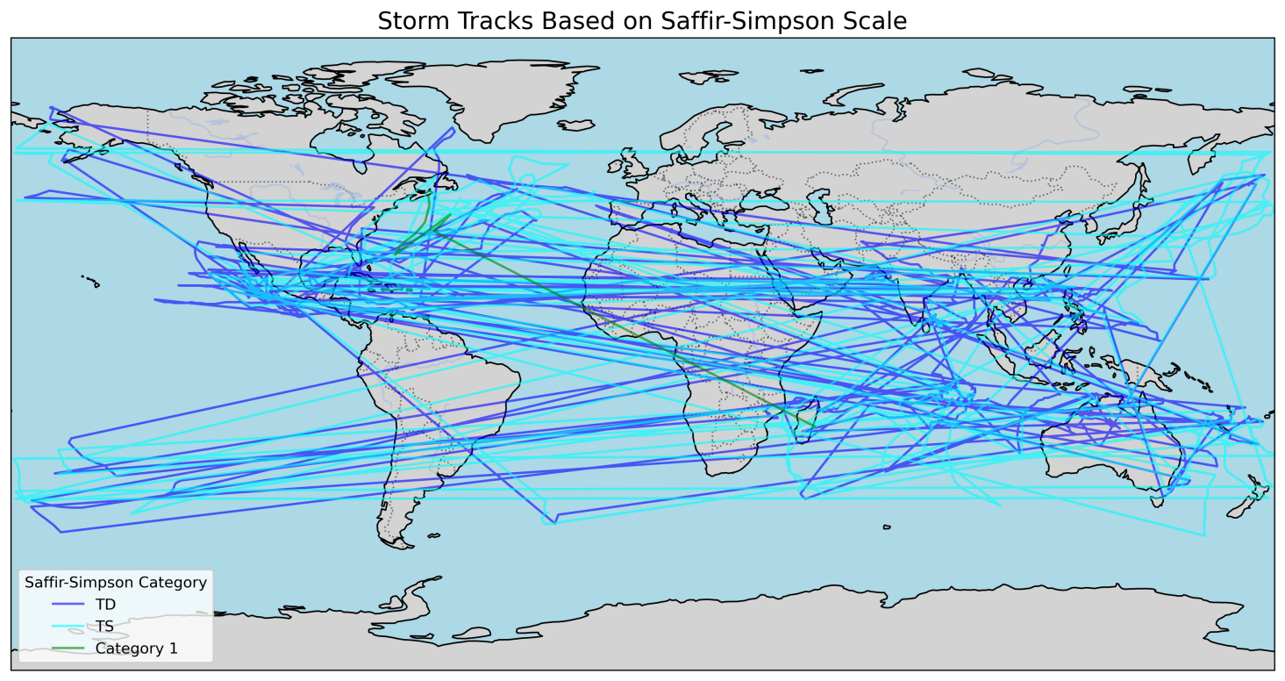

After run **continuous_storm_track.py**, we get below result:

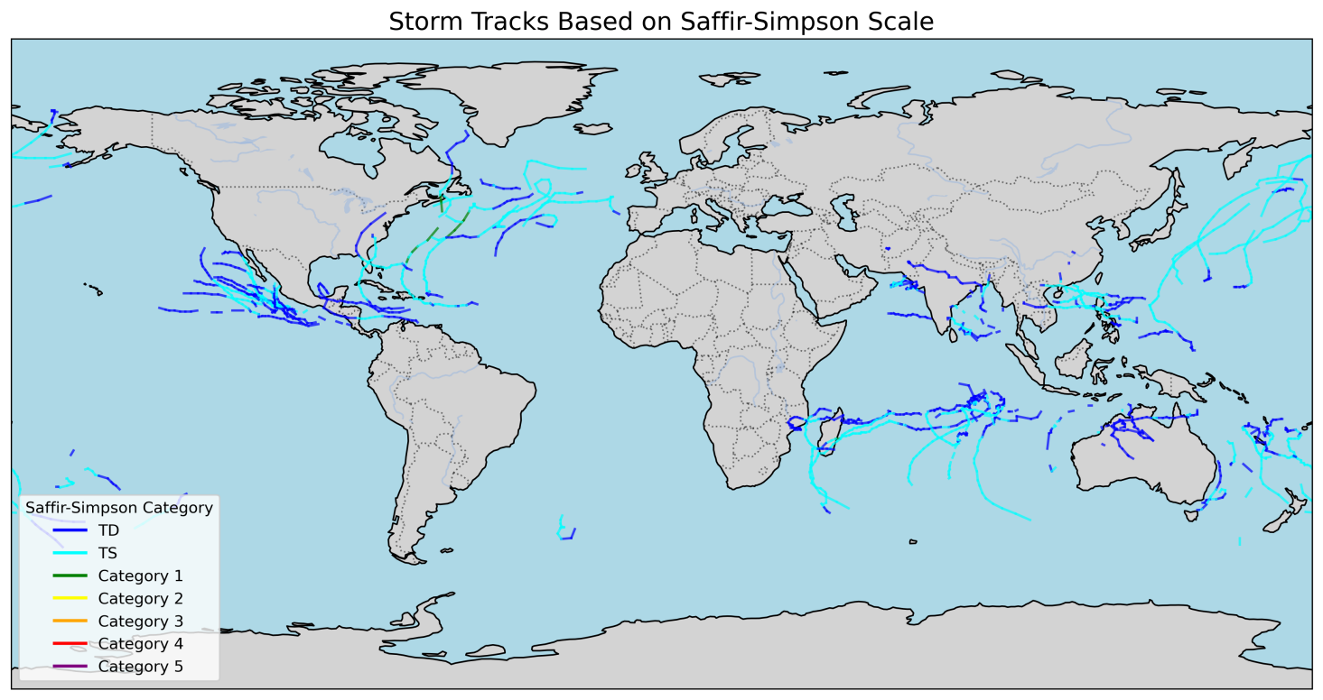

1. Attributes

I delete _FillValue, long_name, units, fmissing_value, standard_name, vmax, vmin, valid_range from ERA5_TE_ready_2022_modified_v5.nc. Then the new dataset can’t run in the TE model.

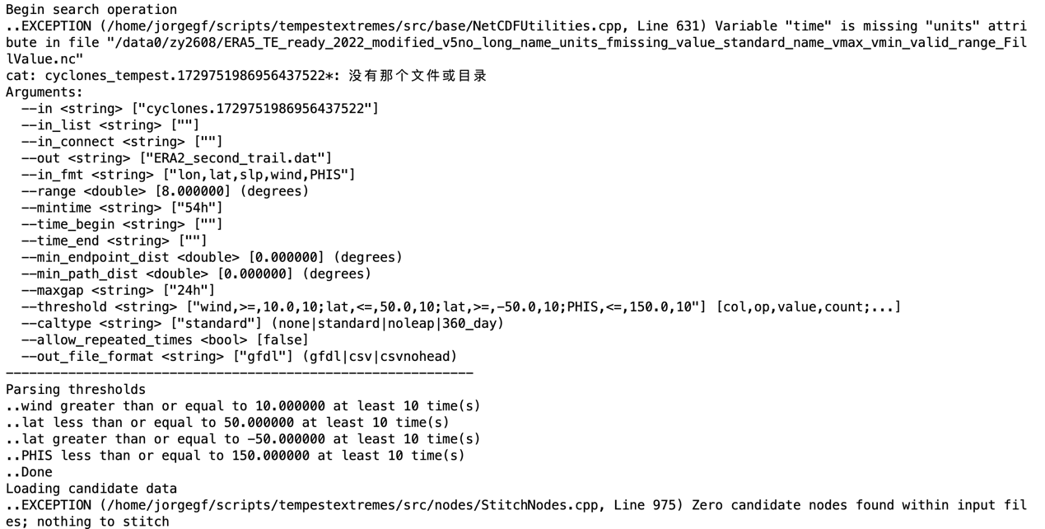

In order to find the more accuracy range, I delete the _FillValue, longname, units. The updated data can’t run again.

Later, I deleted the _FillValue, longname, TE model can run correctly again.

Therefore, I tried to delete only units attribute, TE model can’t run.

‘Units’ is a key attribute when we run TE model.

Therefore, I change the units of time from seconds to hour, then the original dataset can work!

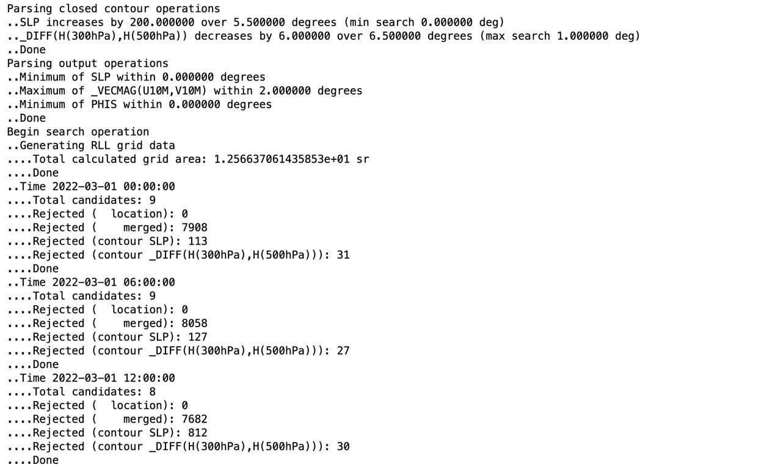

1. Paper

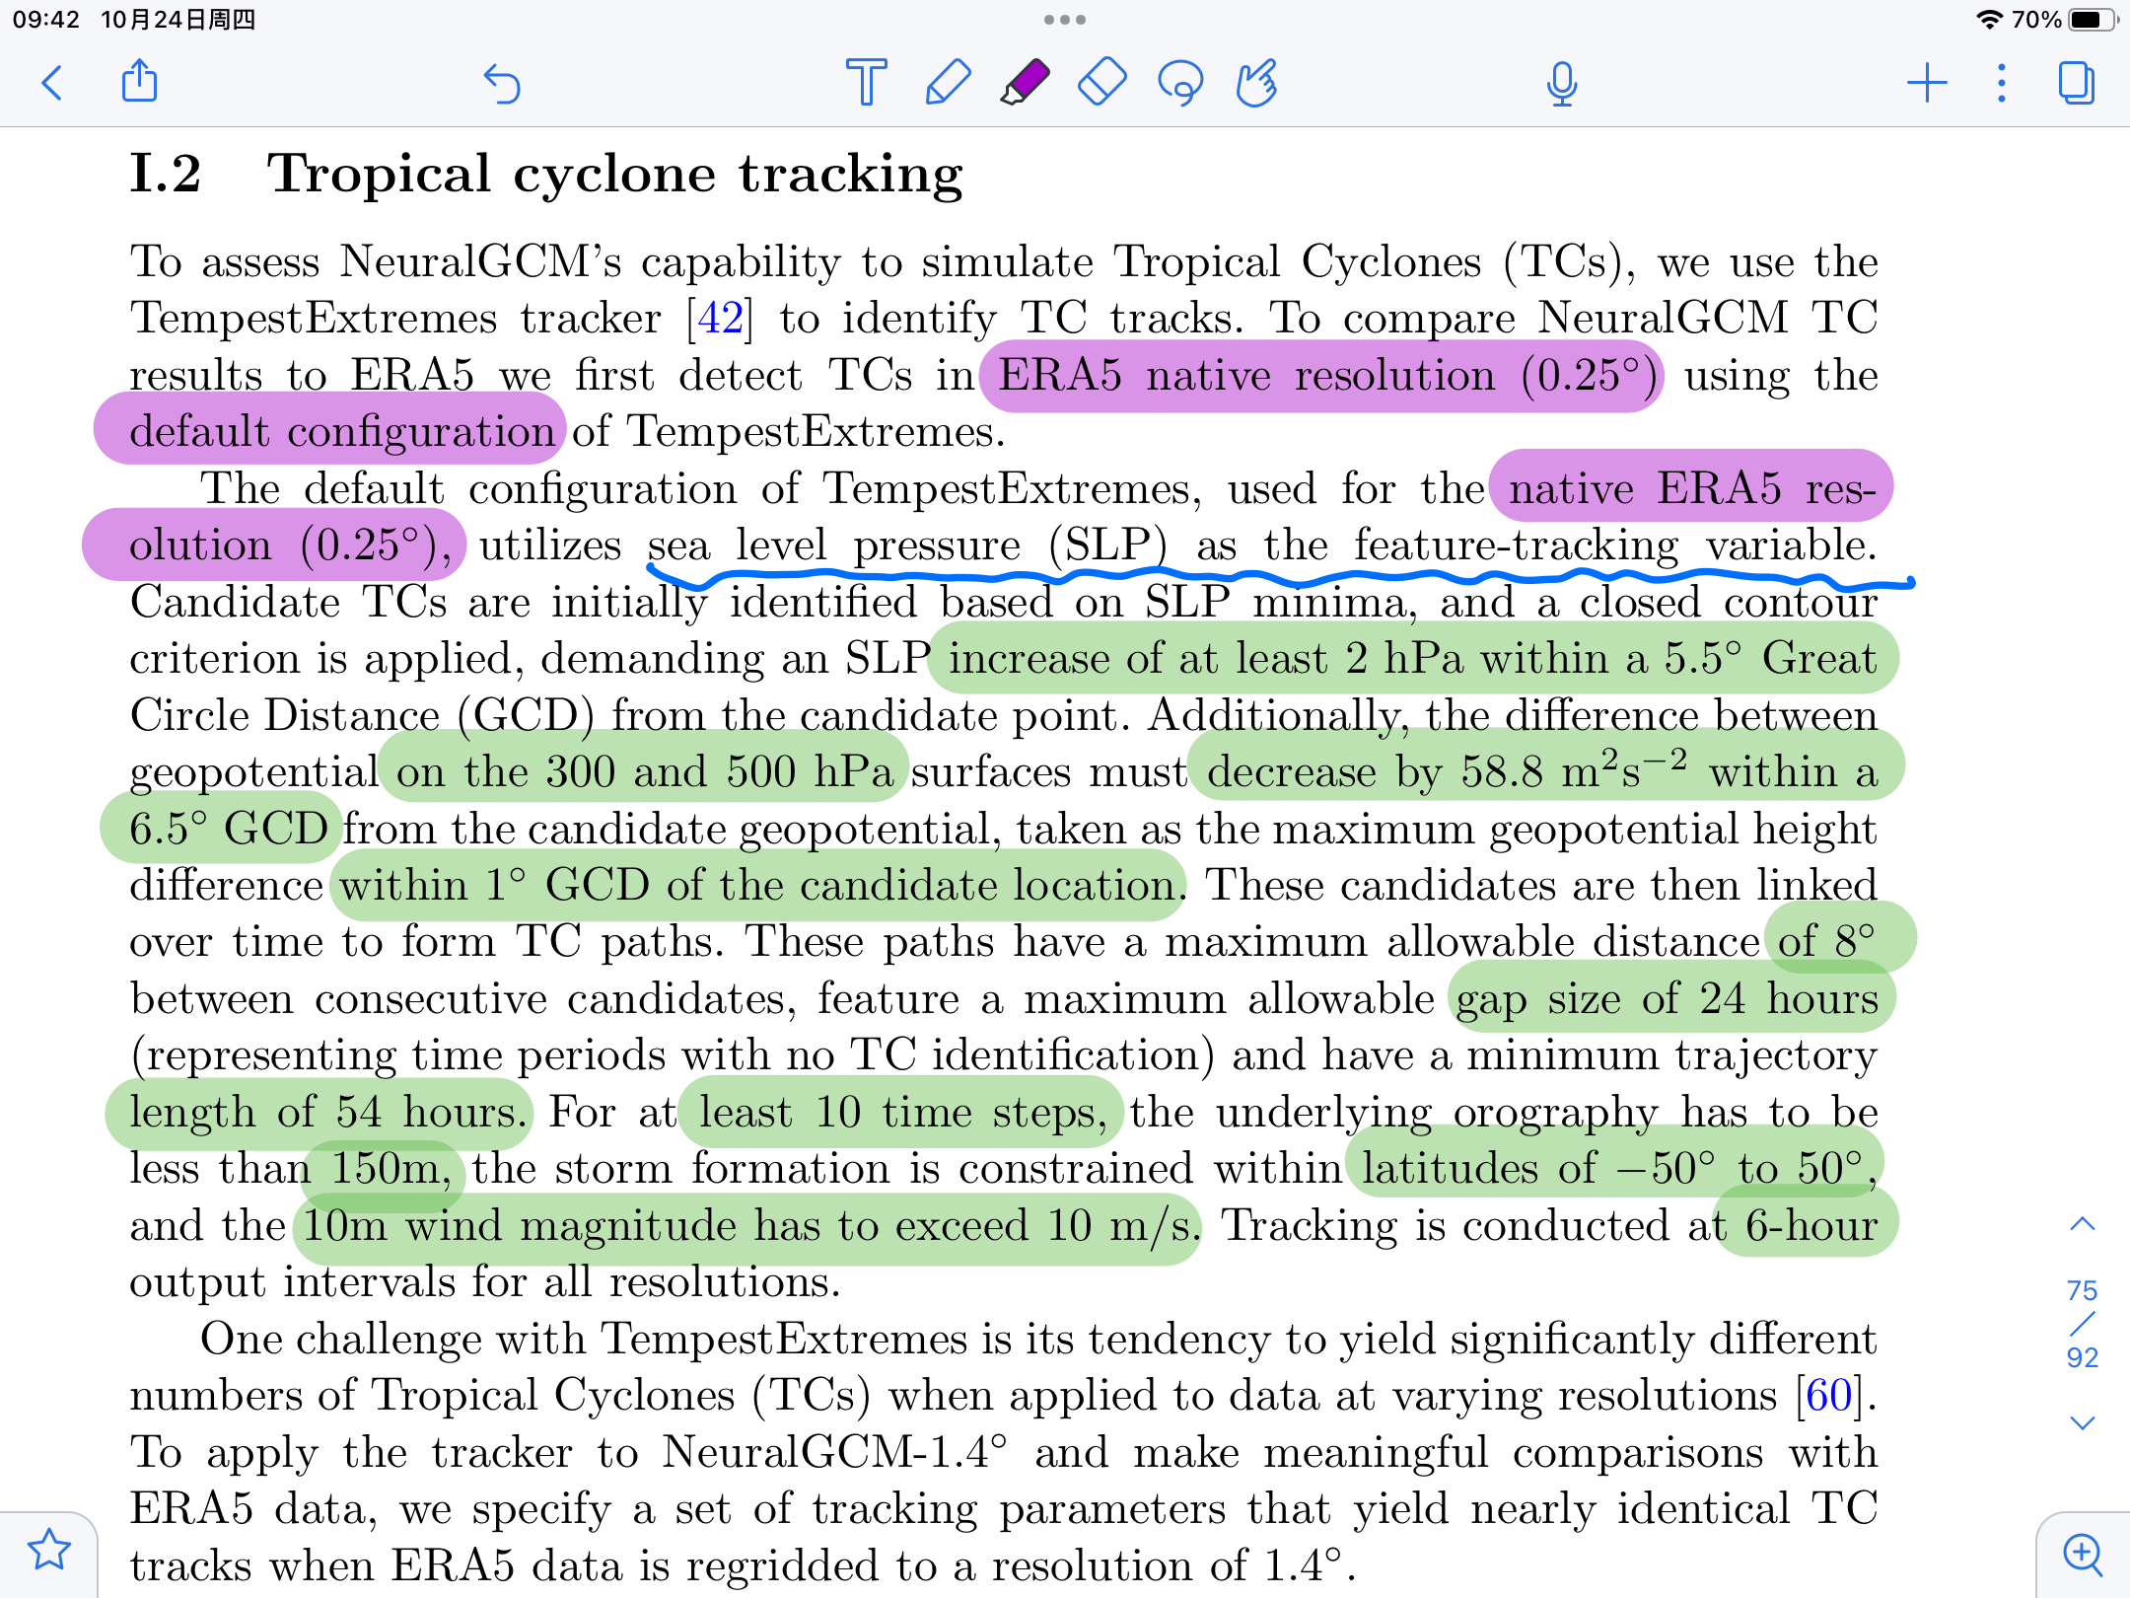

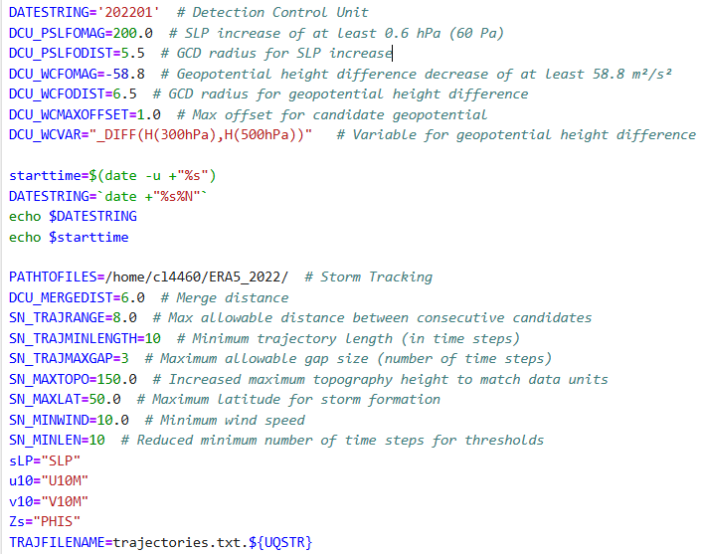

But the problem here is that when we set the value of DCU_WCFOMAG to -58.8, the output dat file we set is blank, and the cyclone file has the following data in the interim:

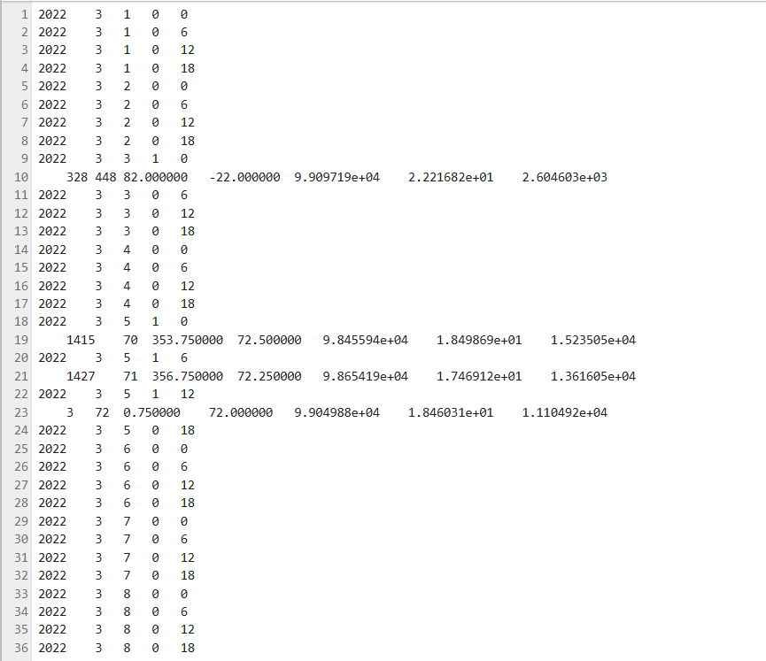

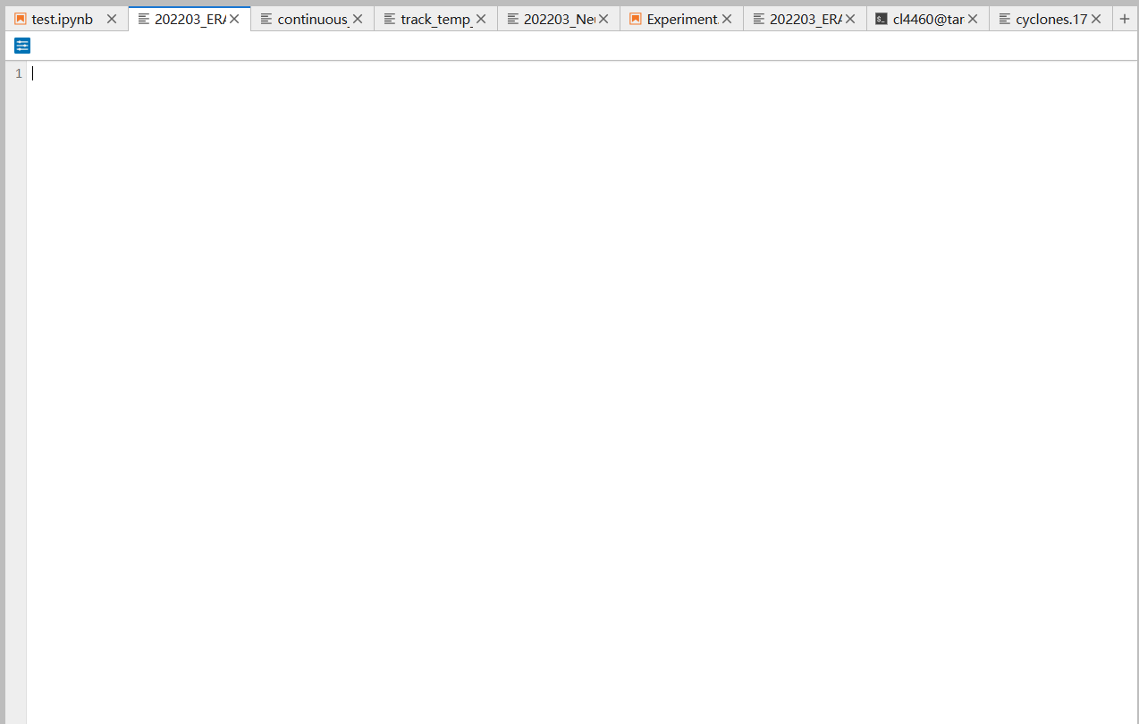

The paper mentions that “The default configuration of TE, used for the native ERA4 resolution (0.25°), SLP as the feature-tracking variable.

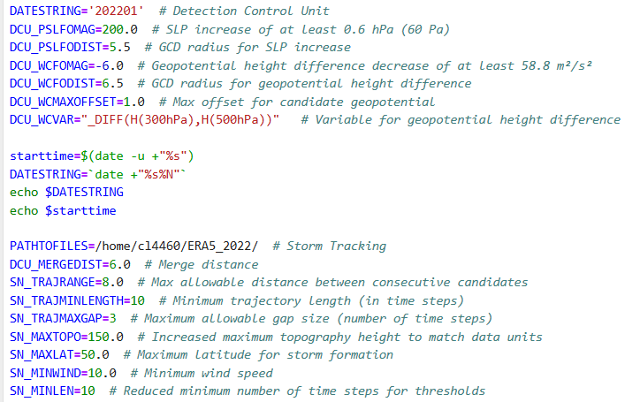

It means we will continue to use the ERA5 data in 2022.

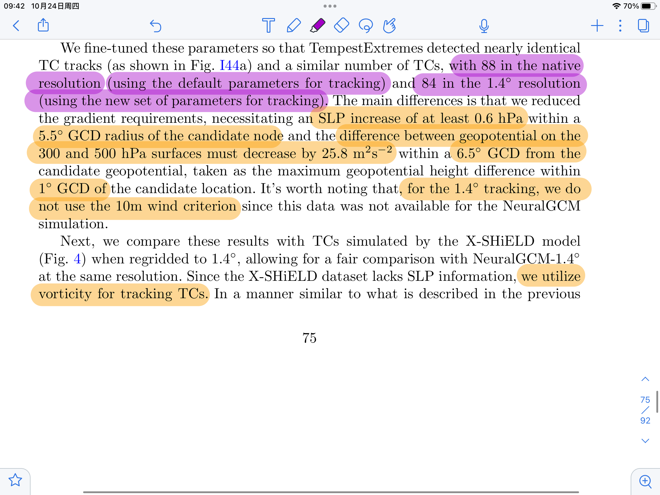

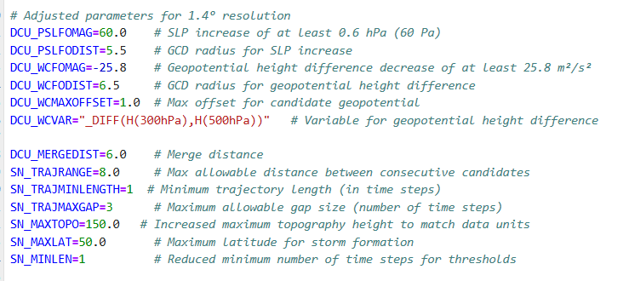

After get data, we run the **labeldata.py** to get dataset:

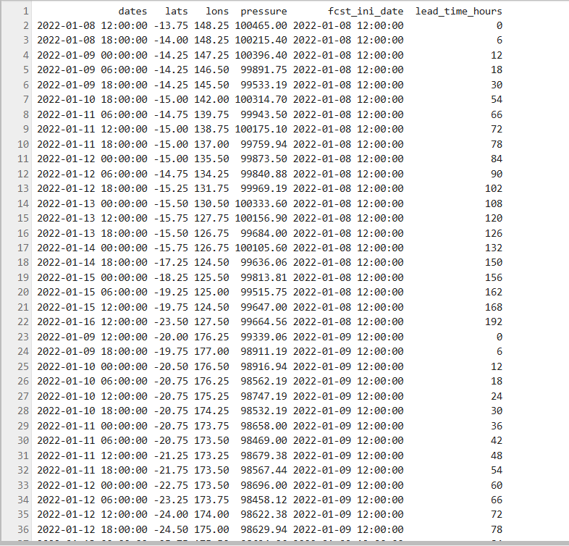

Some csv problems happened, try to run **csv_convert.py**:

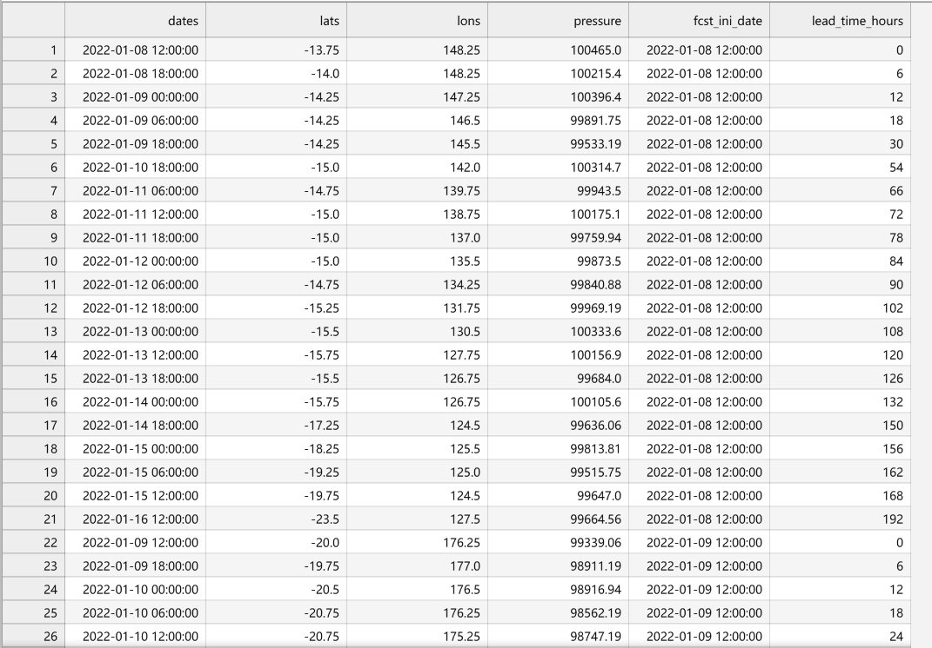

To run **1.4°continuous.py**:

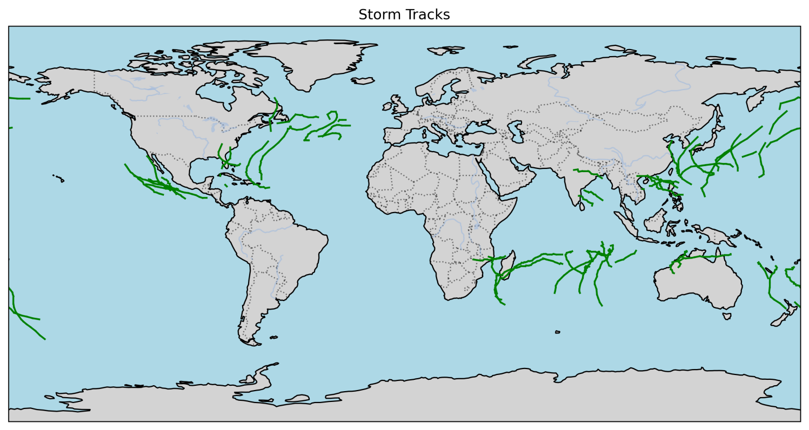

Continuous to convert ERA5.dat to csv format, run **0.25°csv_convert.py**:

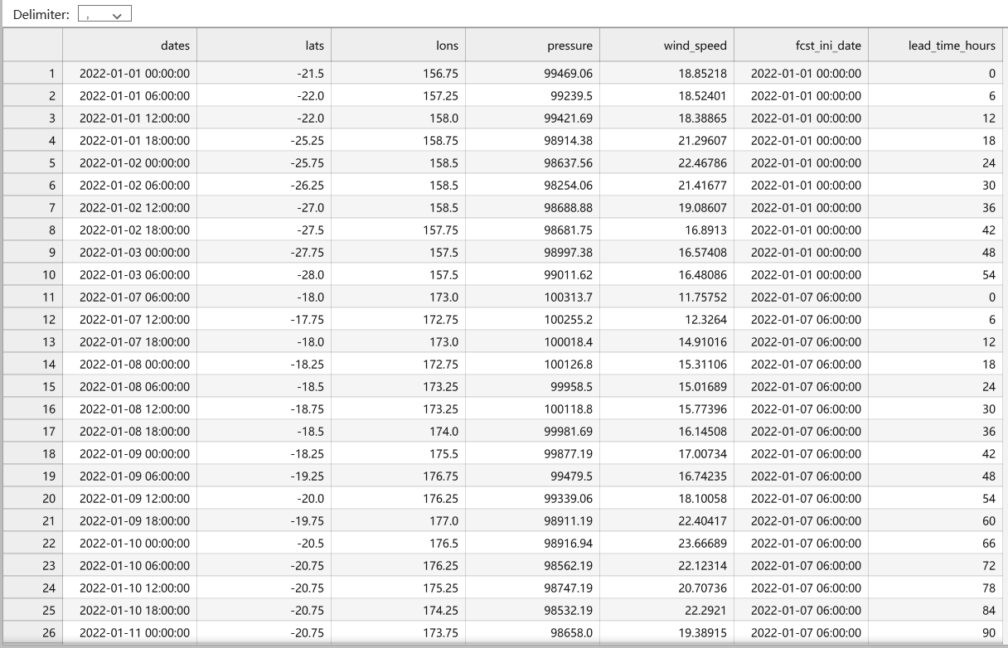

Combine these two csv files together to get the graph, run **combine.py**:

